

**ASSIGNMENT 6**

[Design of a combinational logic circuit for **ODD/EVEN PARITY GENERATOR AND CHECKER** using 2 input NAND GATES]



**NAME: ROHIT SADHU**

**ROLL NO.: 002010501074**



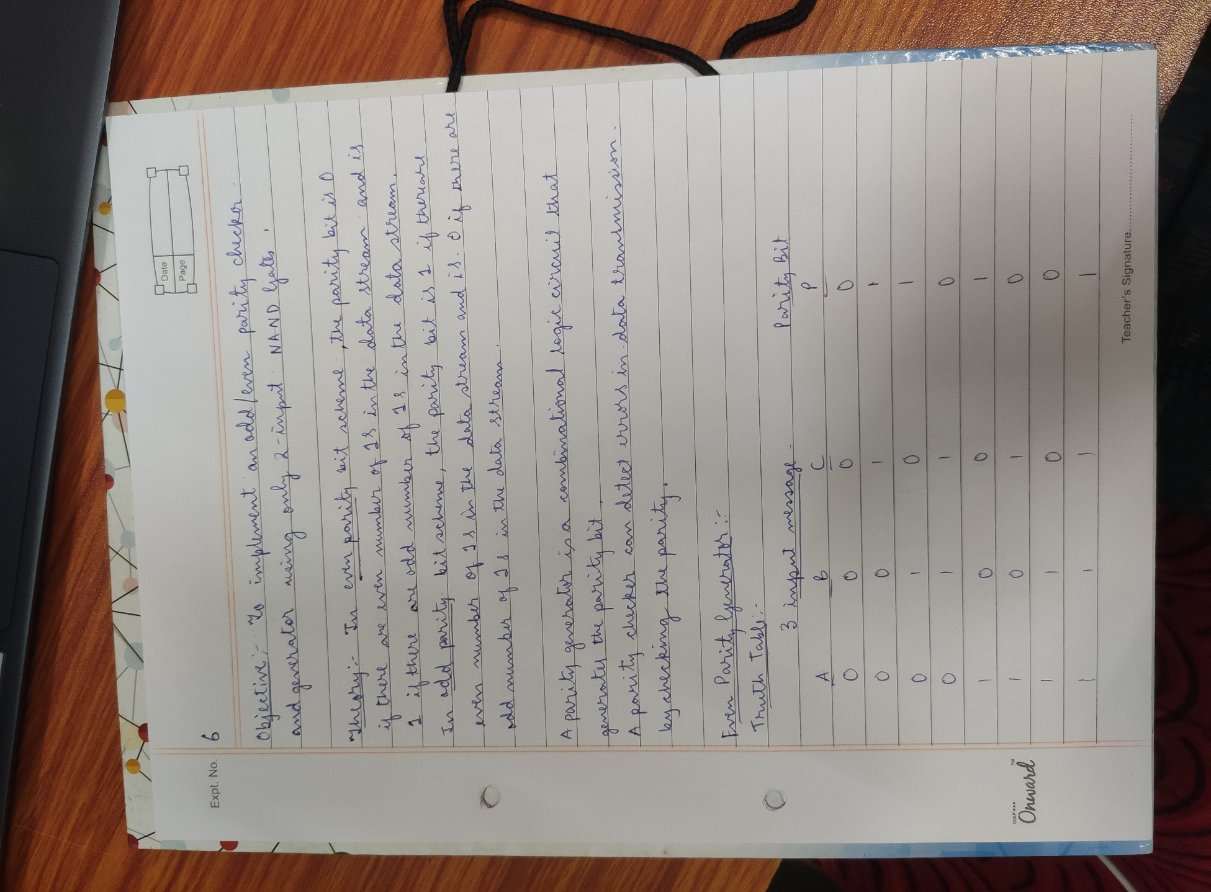

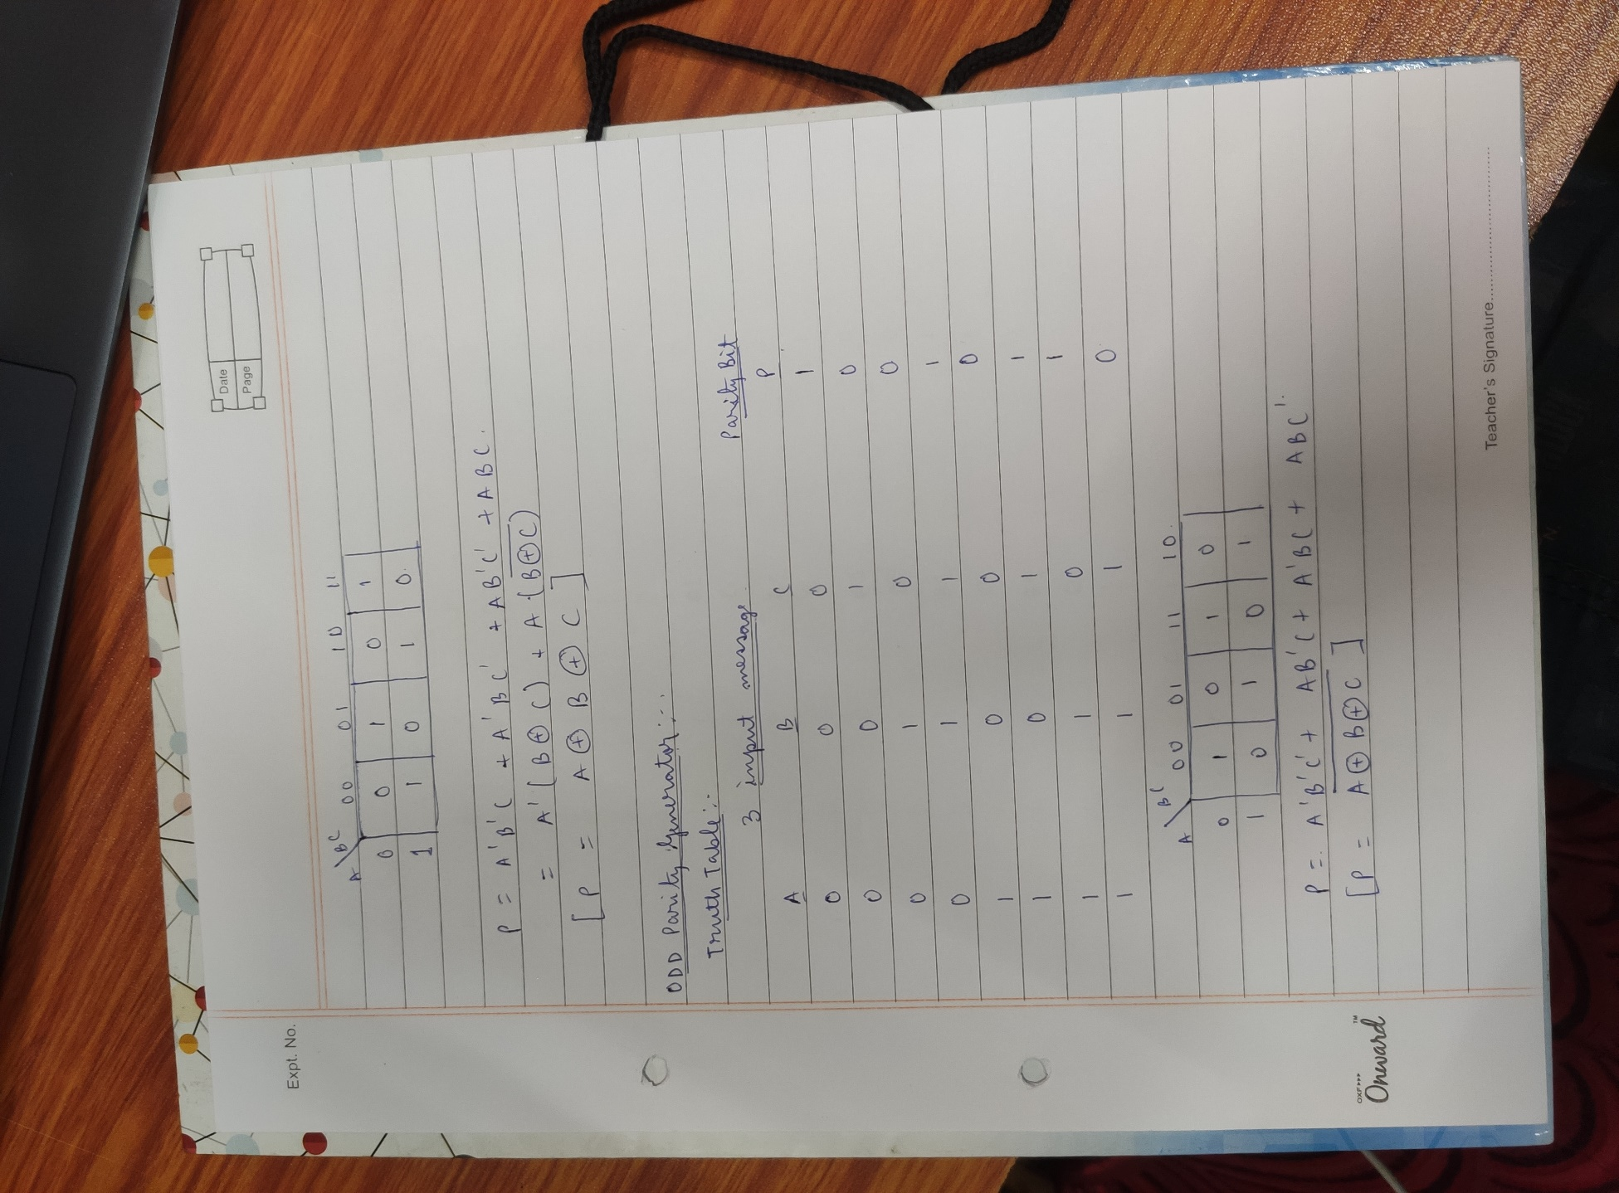

**CIRCUIT DIAGRAM:**

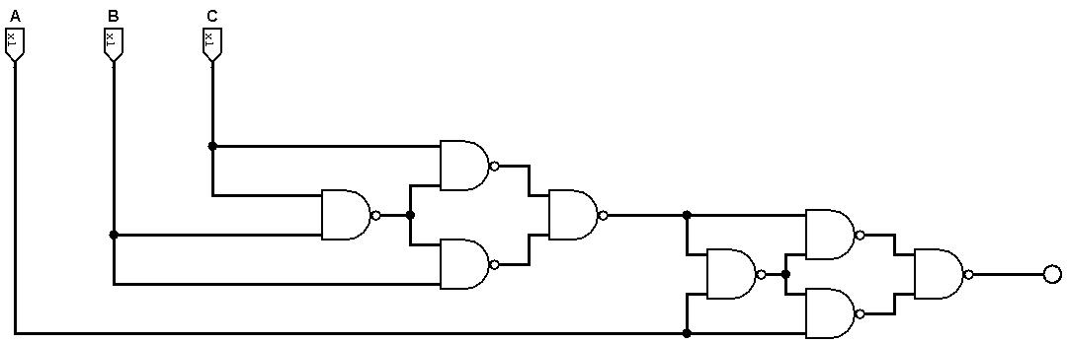**EVEN PARITY GENERATOR:**

**ODD PARITY GENERATOR:**

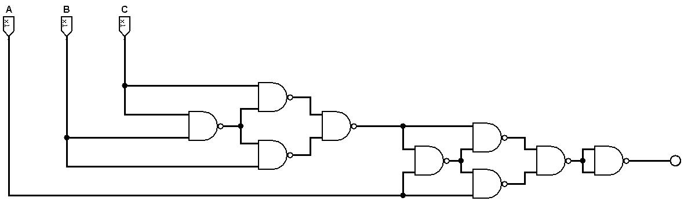

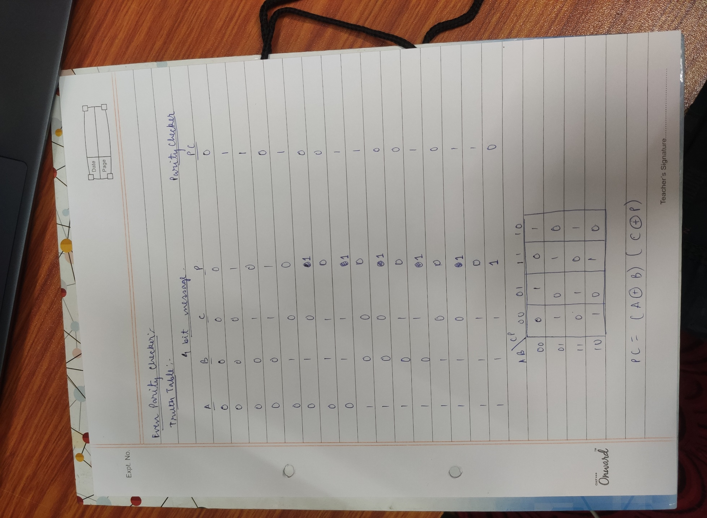

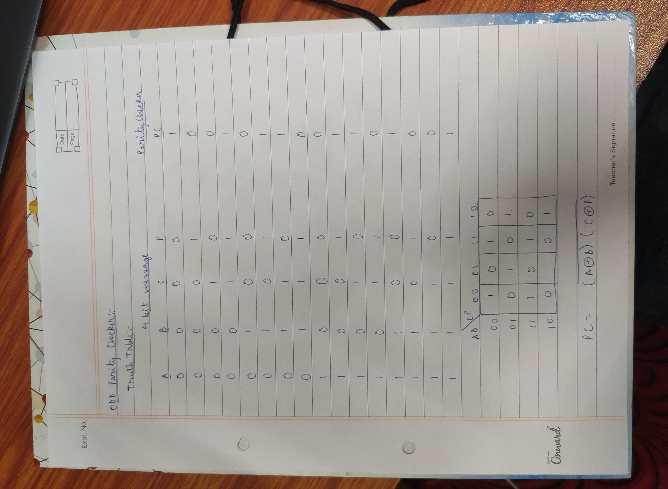

**CIRCUIT DIAGRAM:**

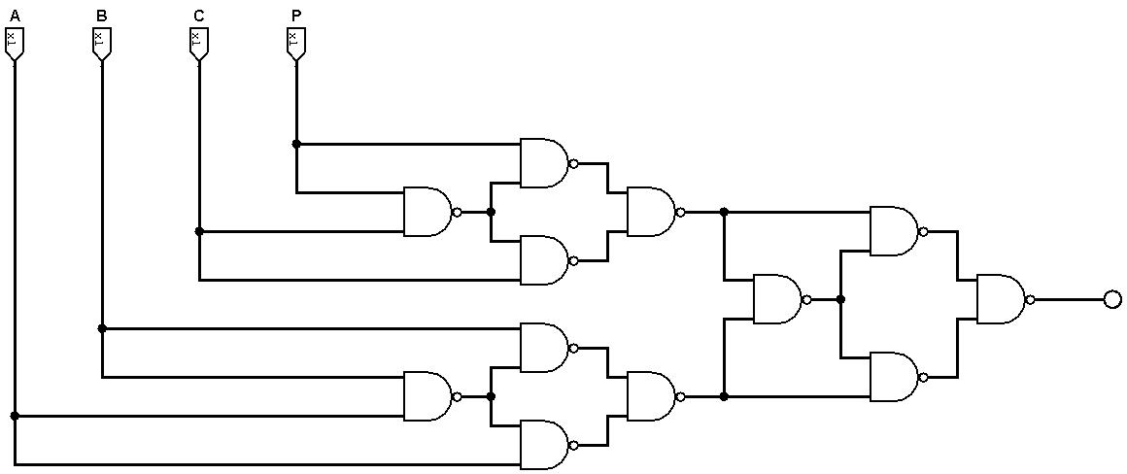**EVEN PARITY CHECKER:**

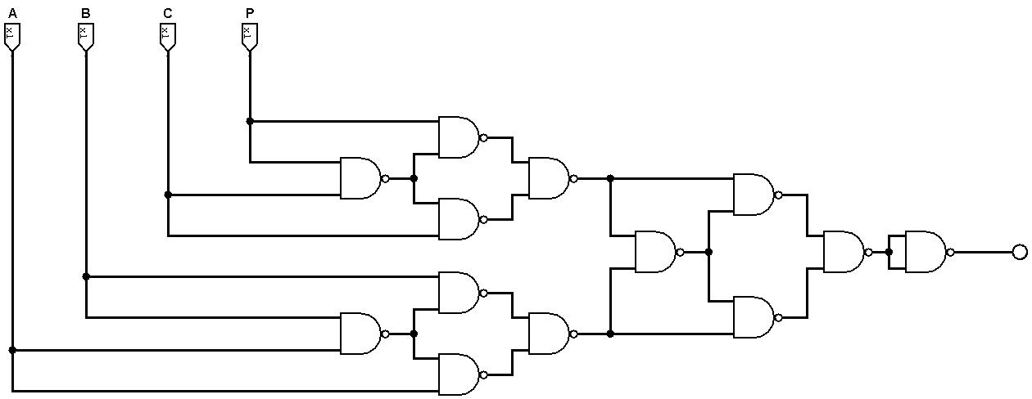**ODD PARITY CHECKER:**